**YUTI NAHA**

**PES1UG23CS723**

**L SECTION**

**CC LAB 2**

**PART 1**

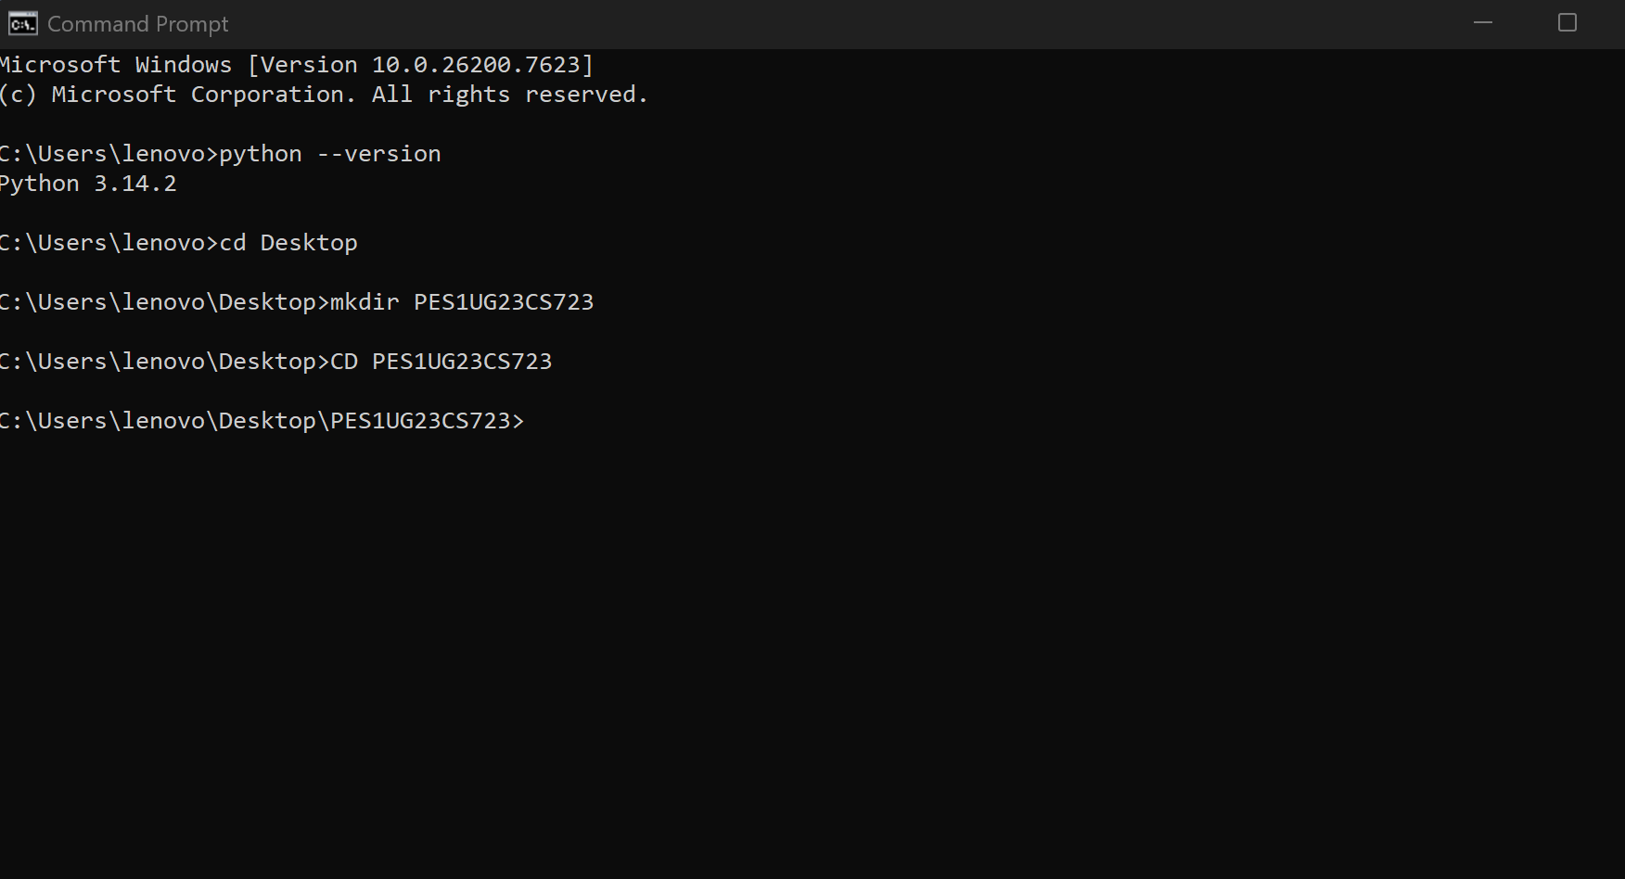

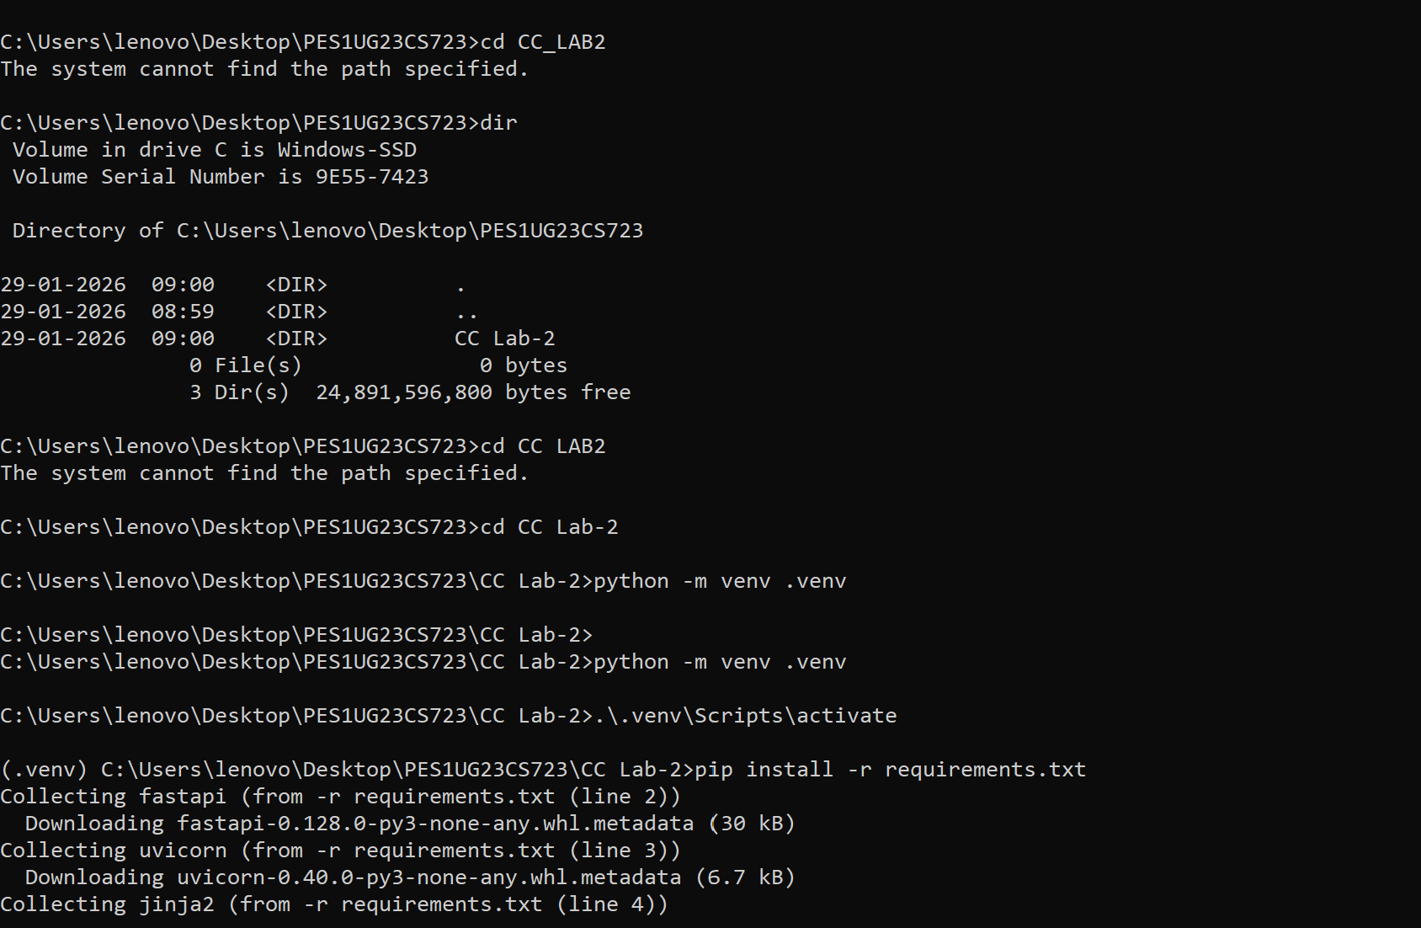

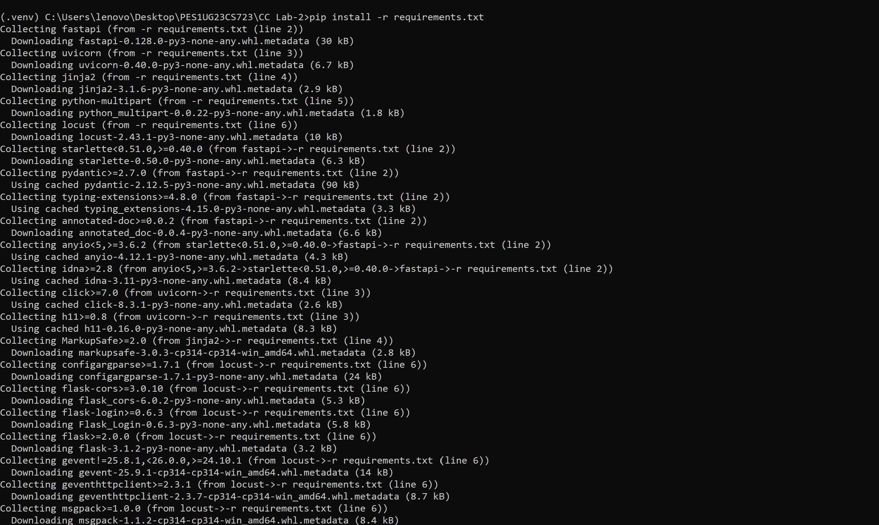



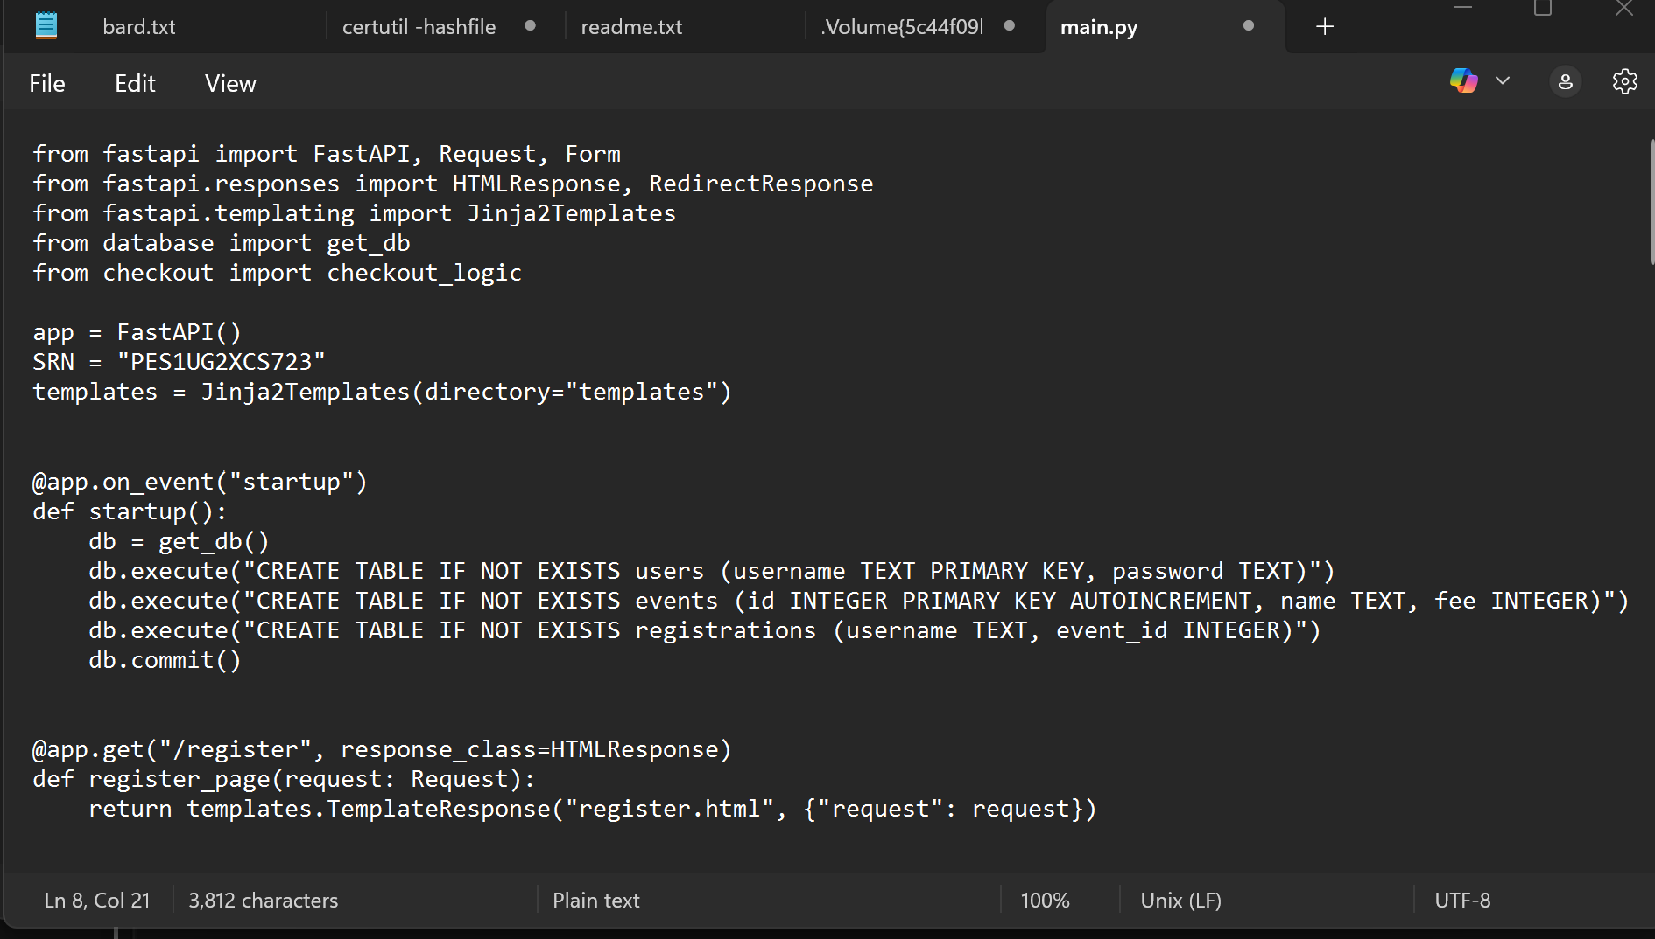

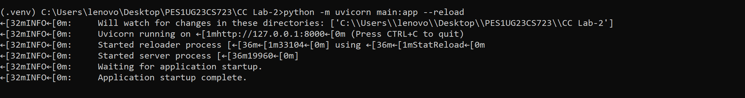

**PART 2**

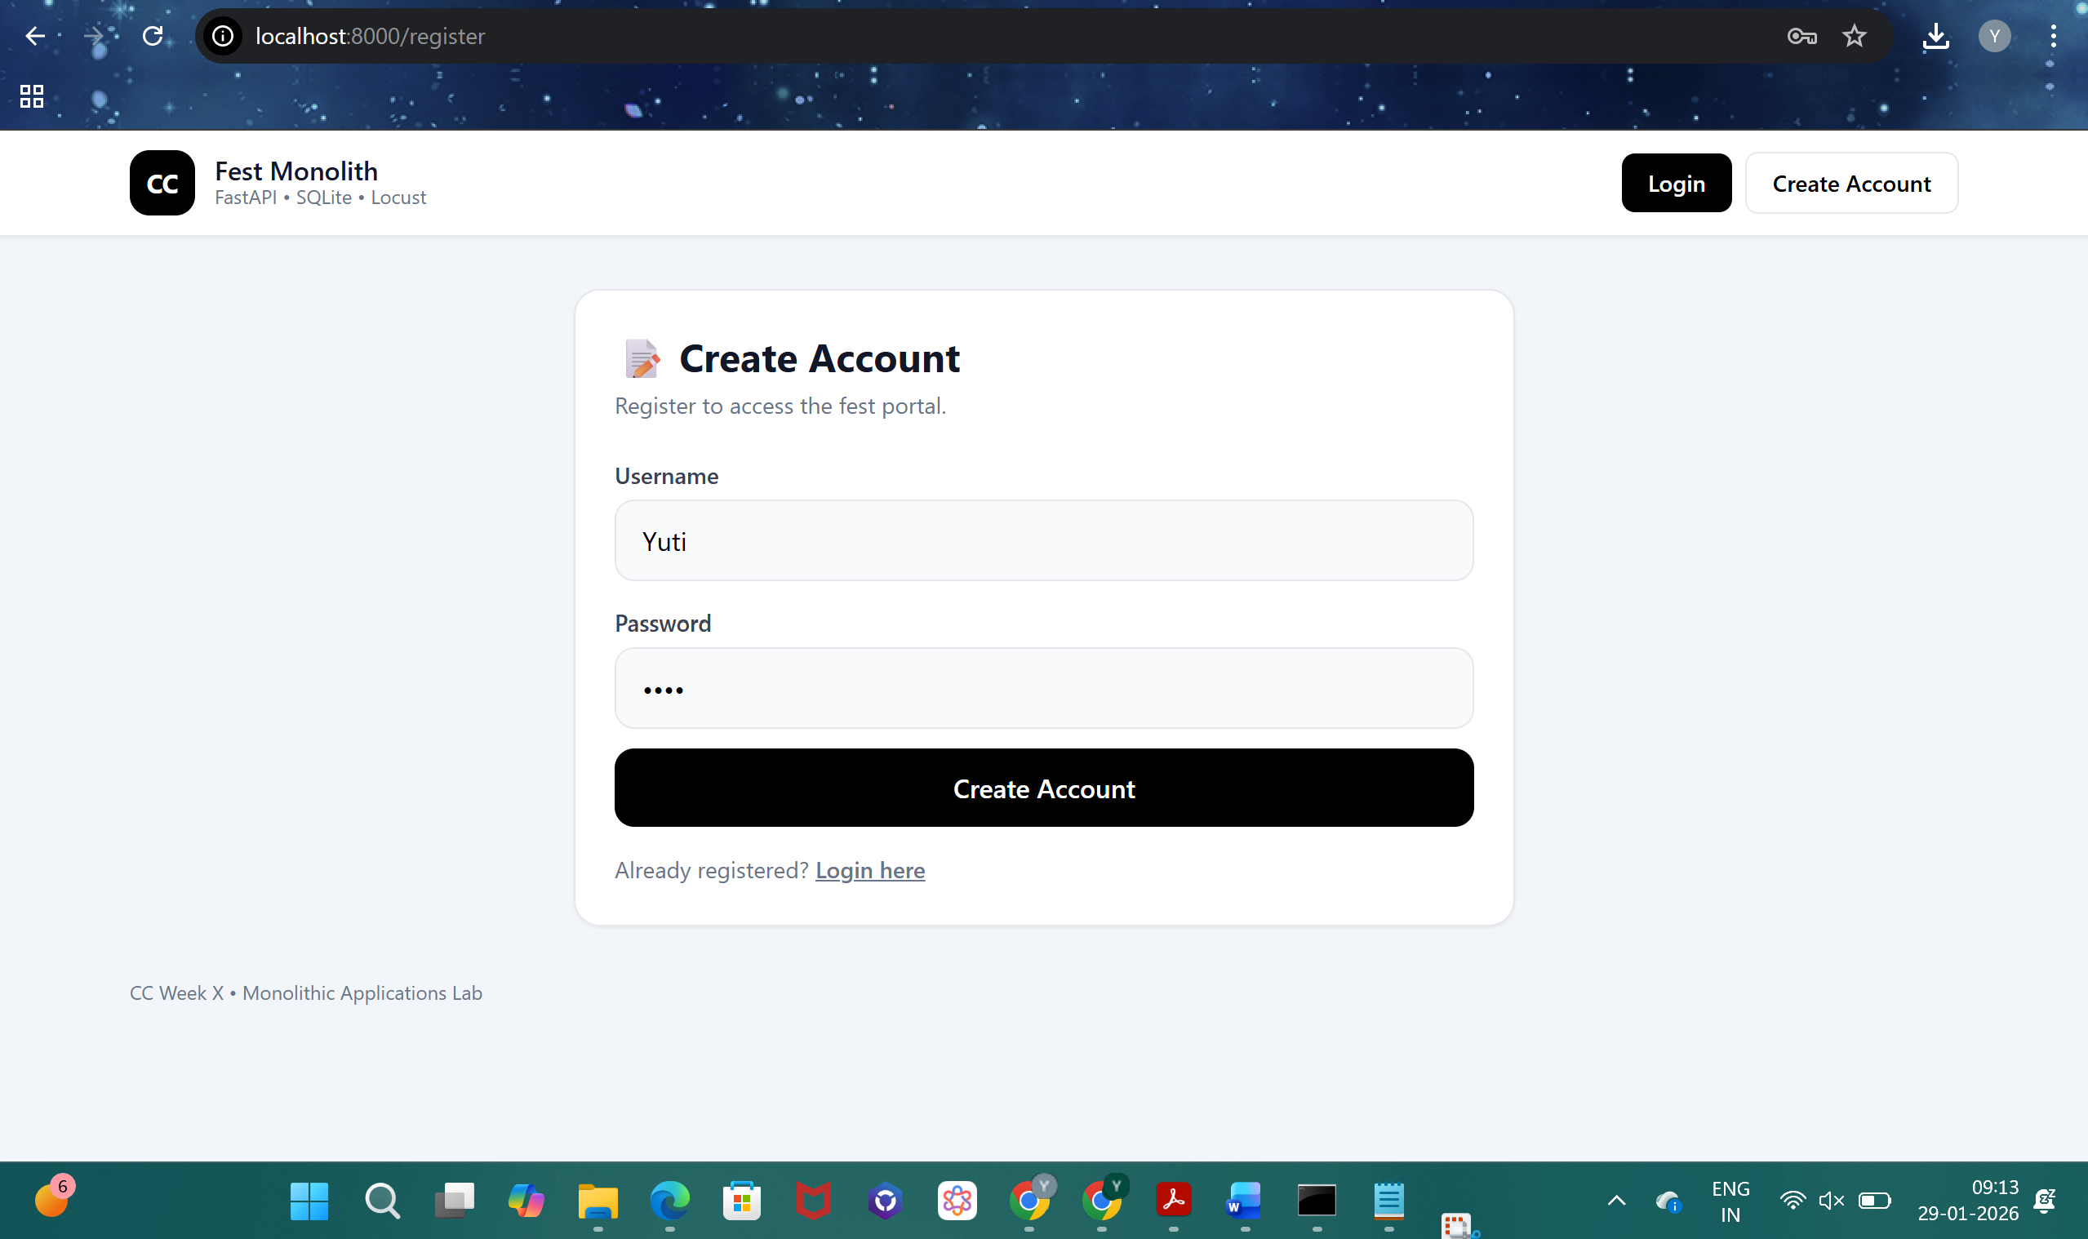

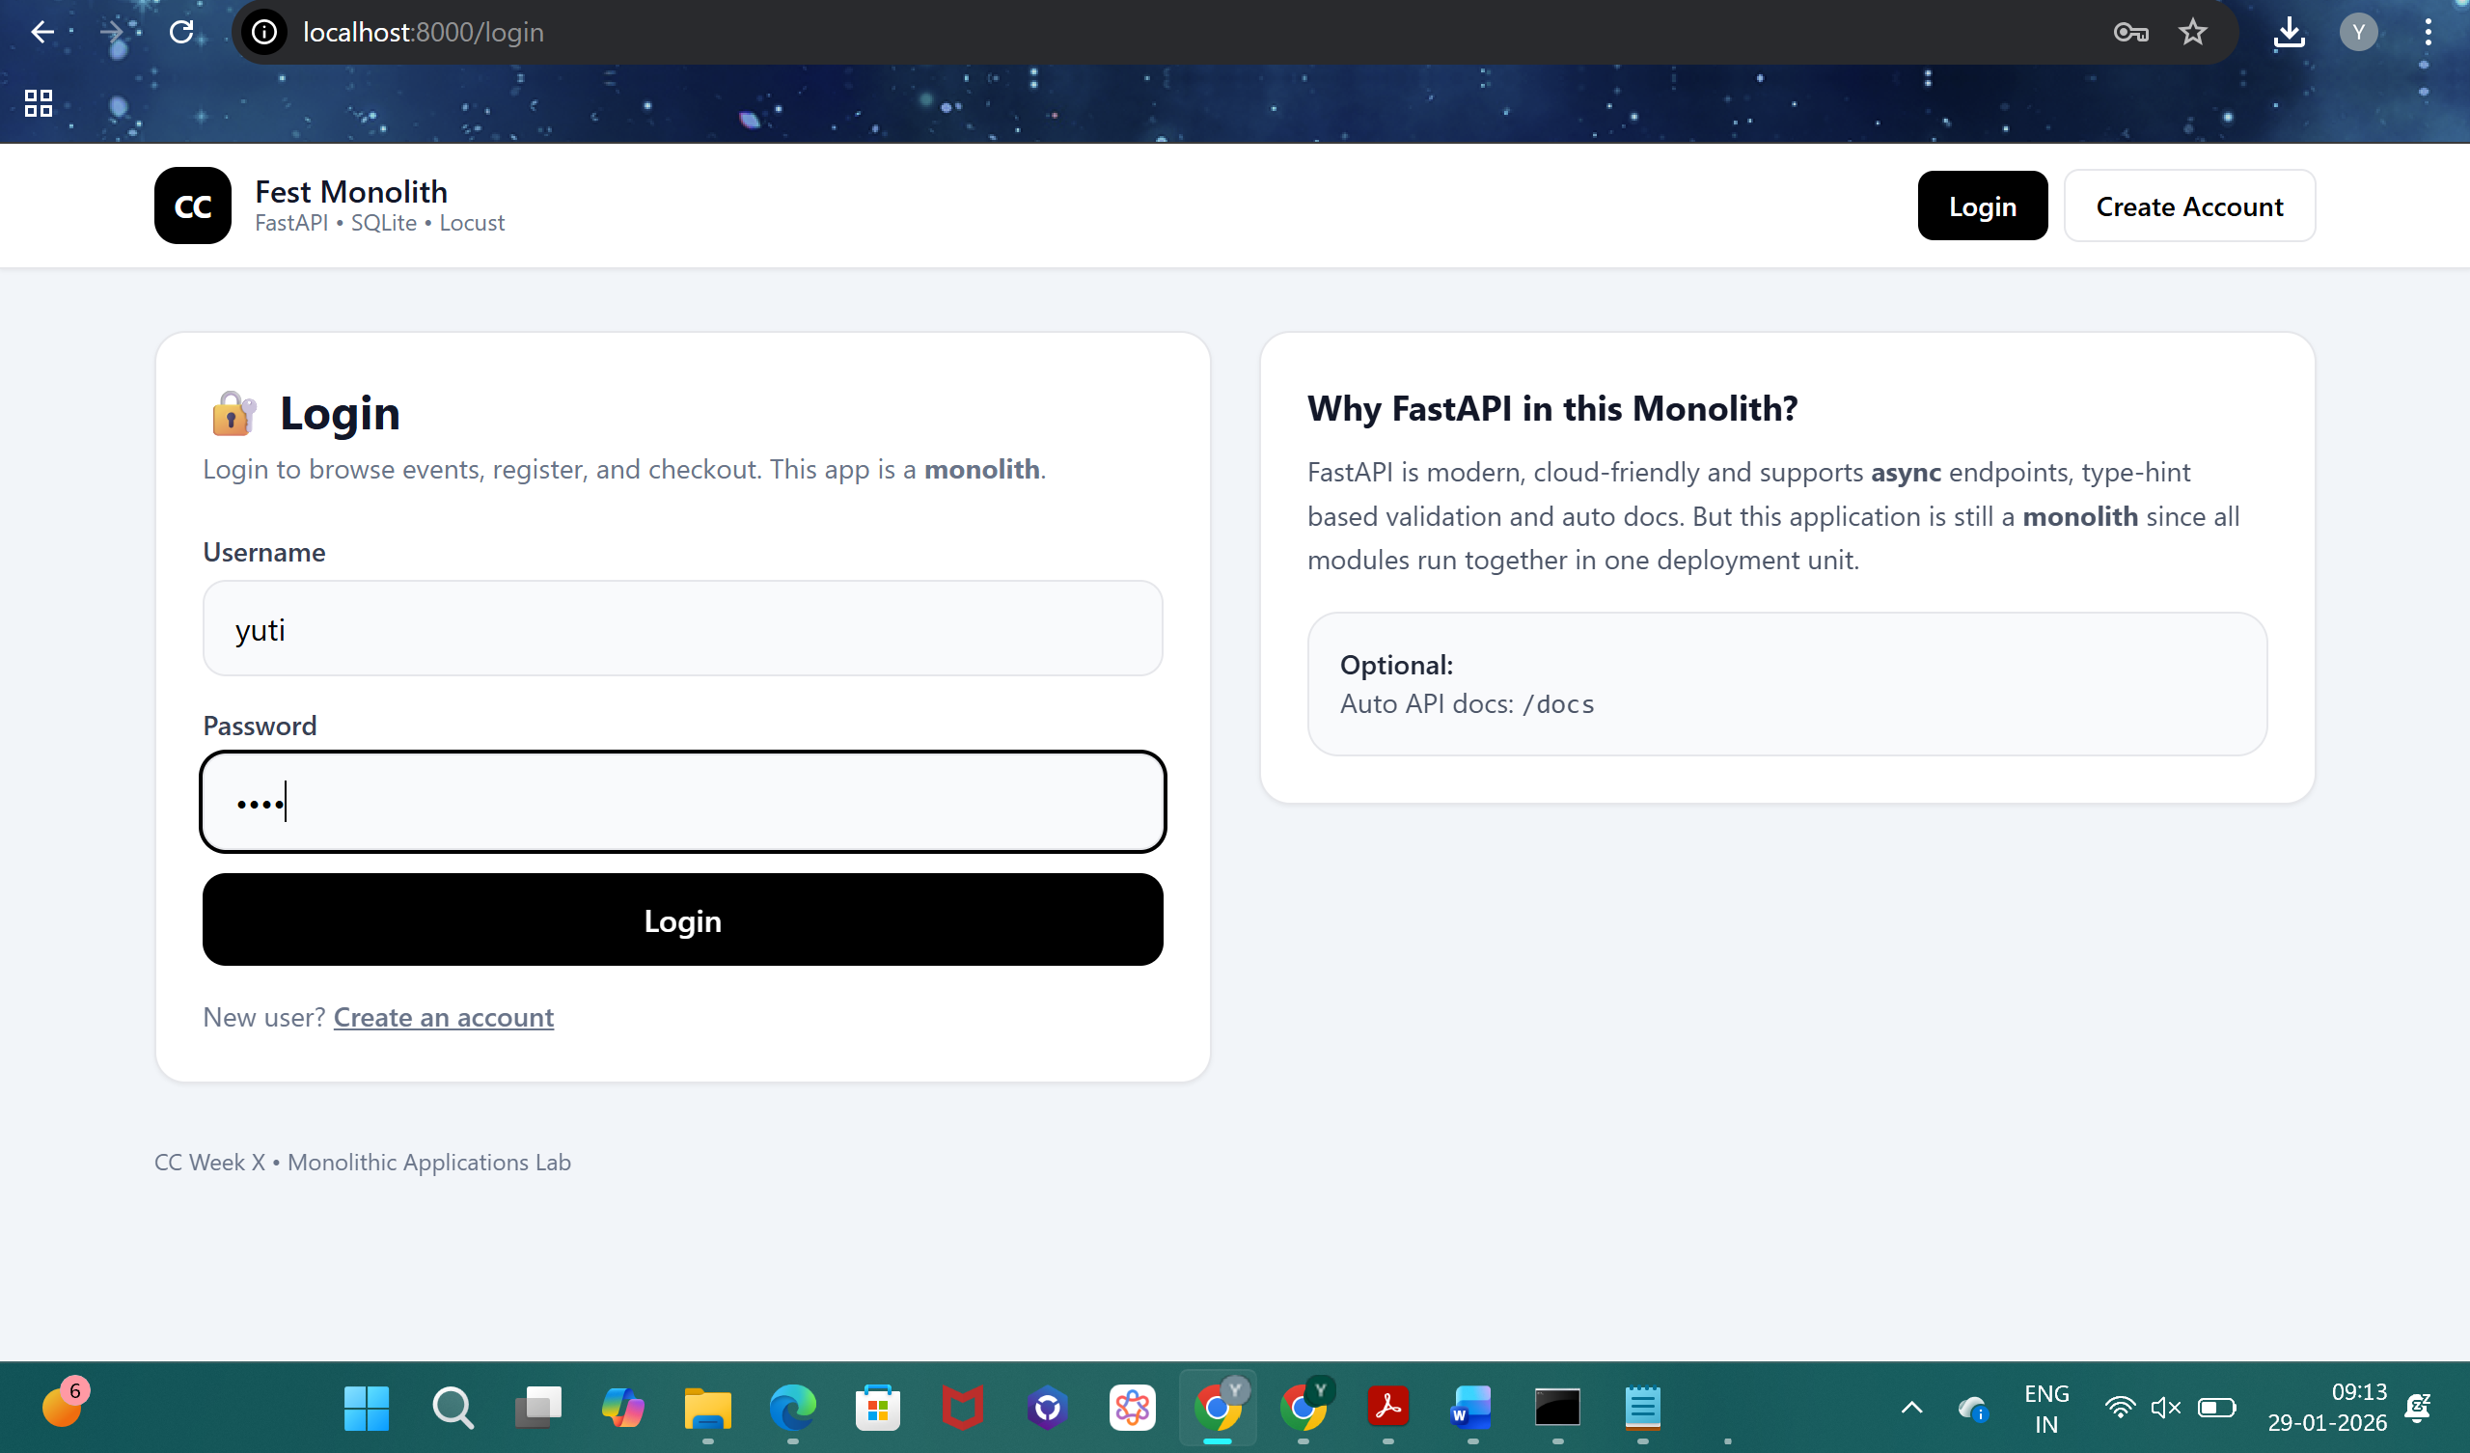

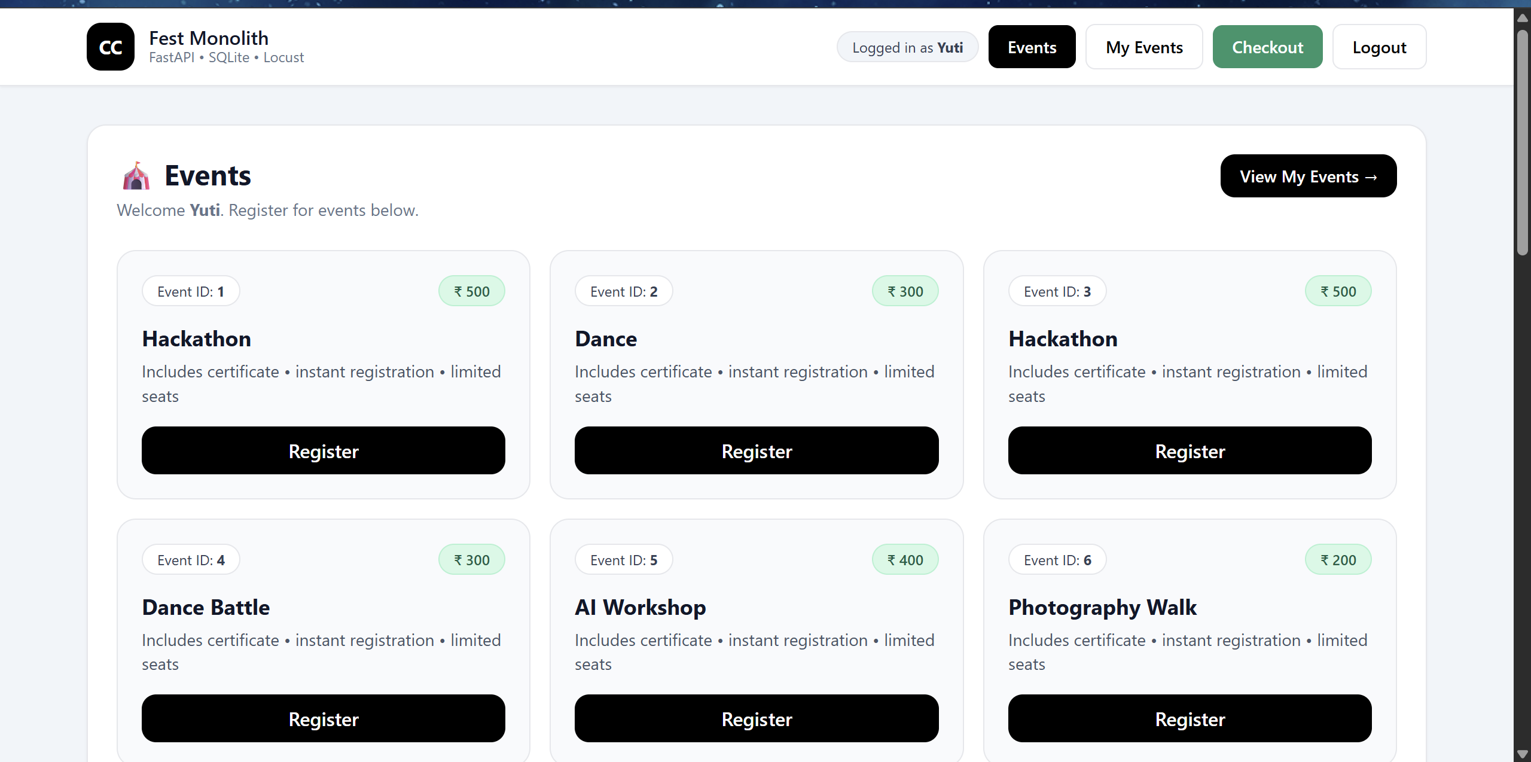

**PART 3**

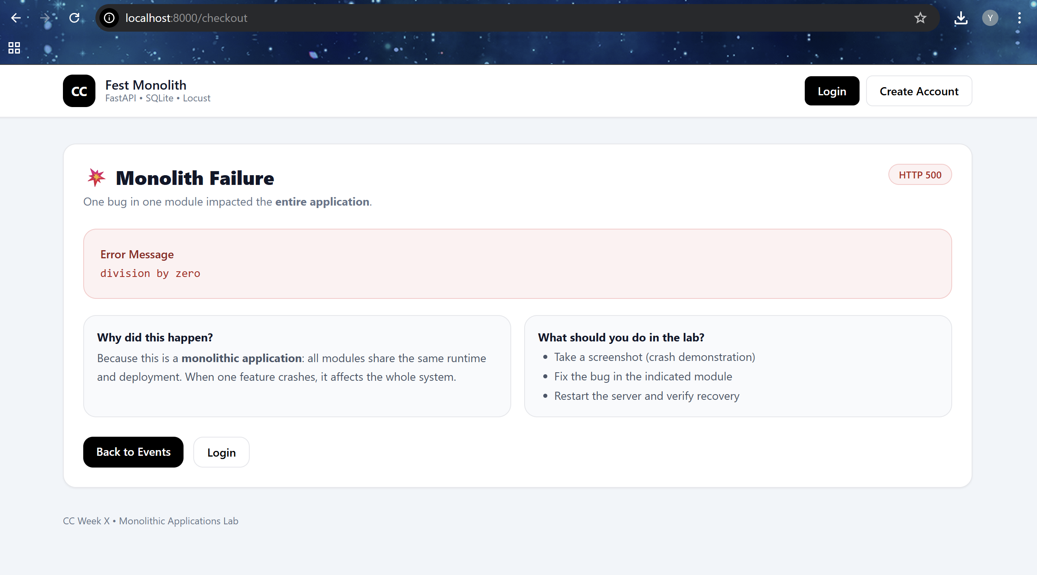



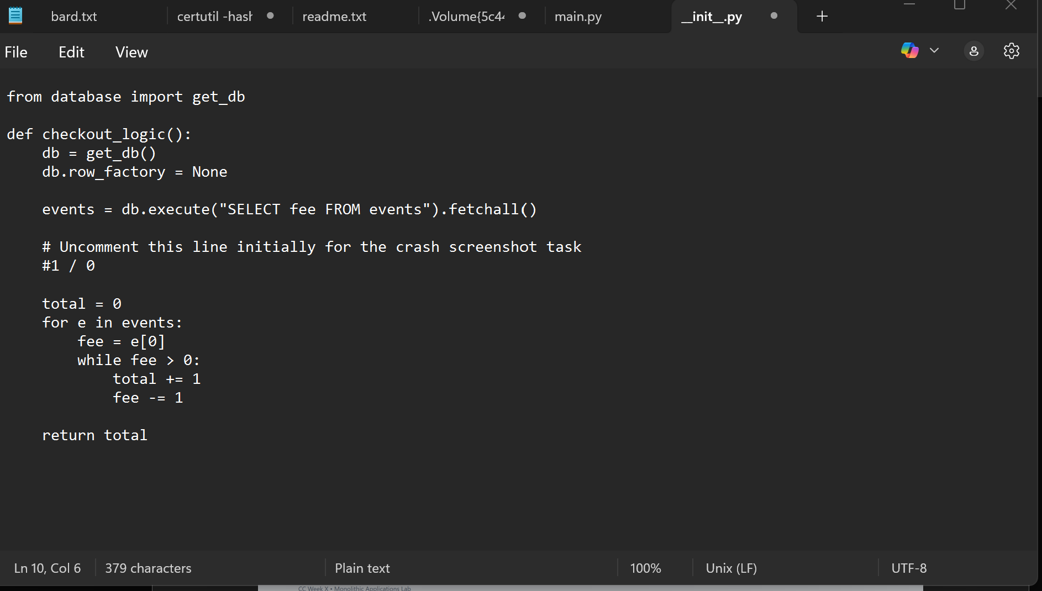

**PART 4**

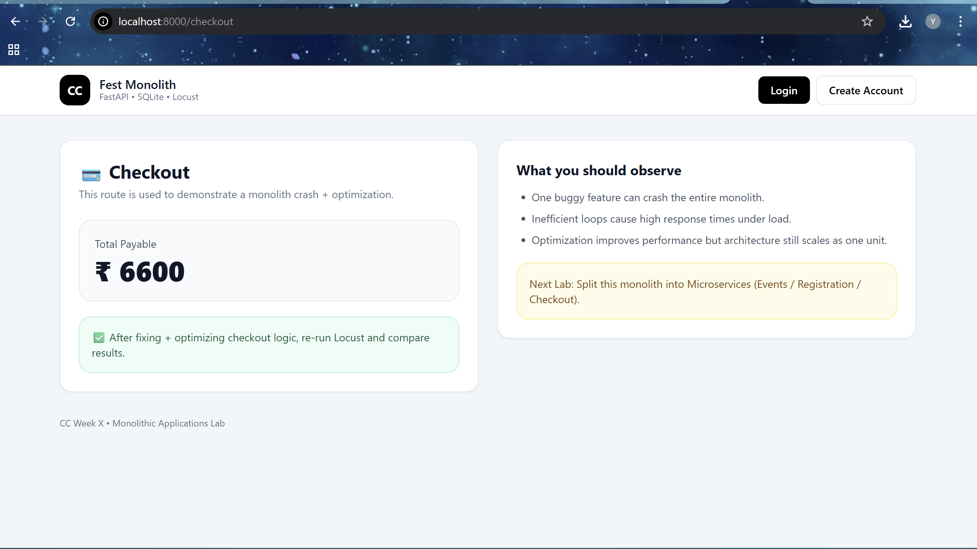

**PART 5**

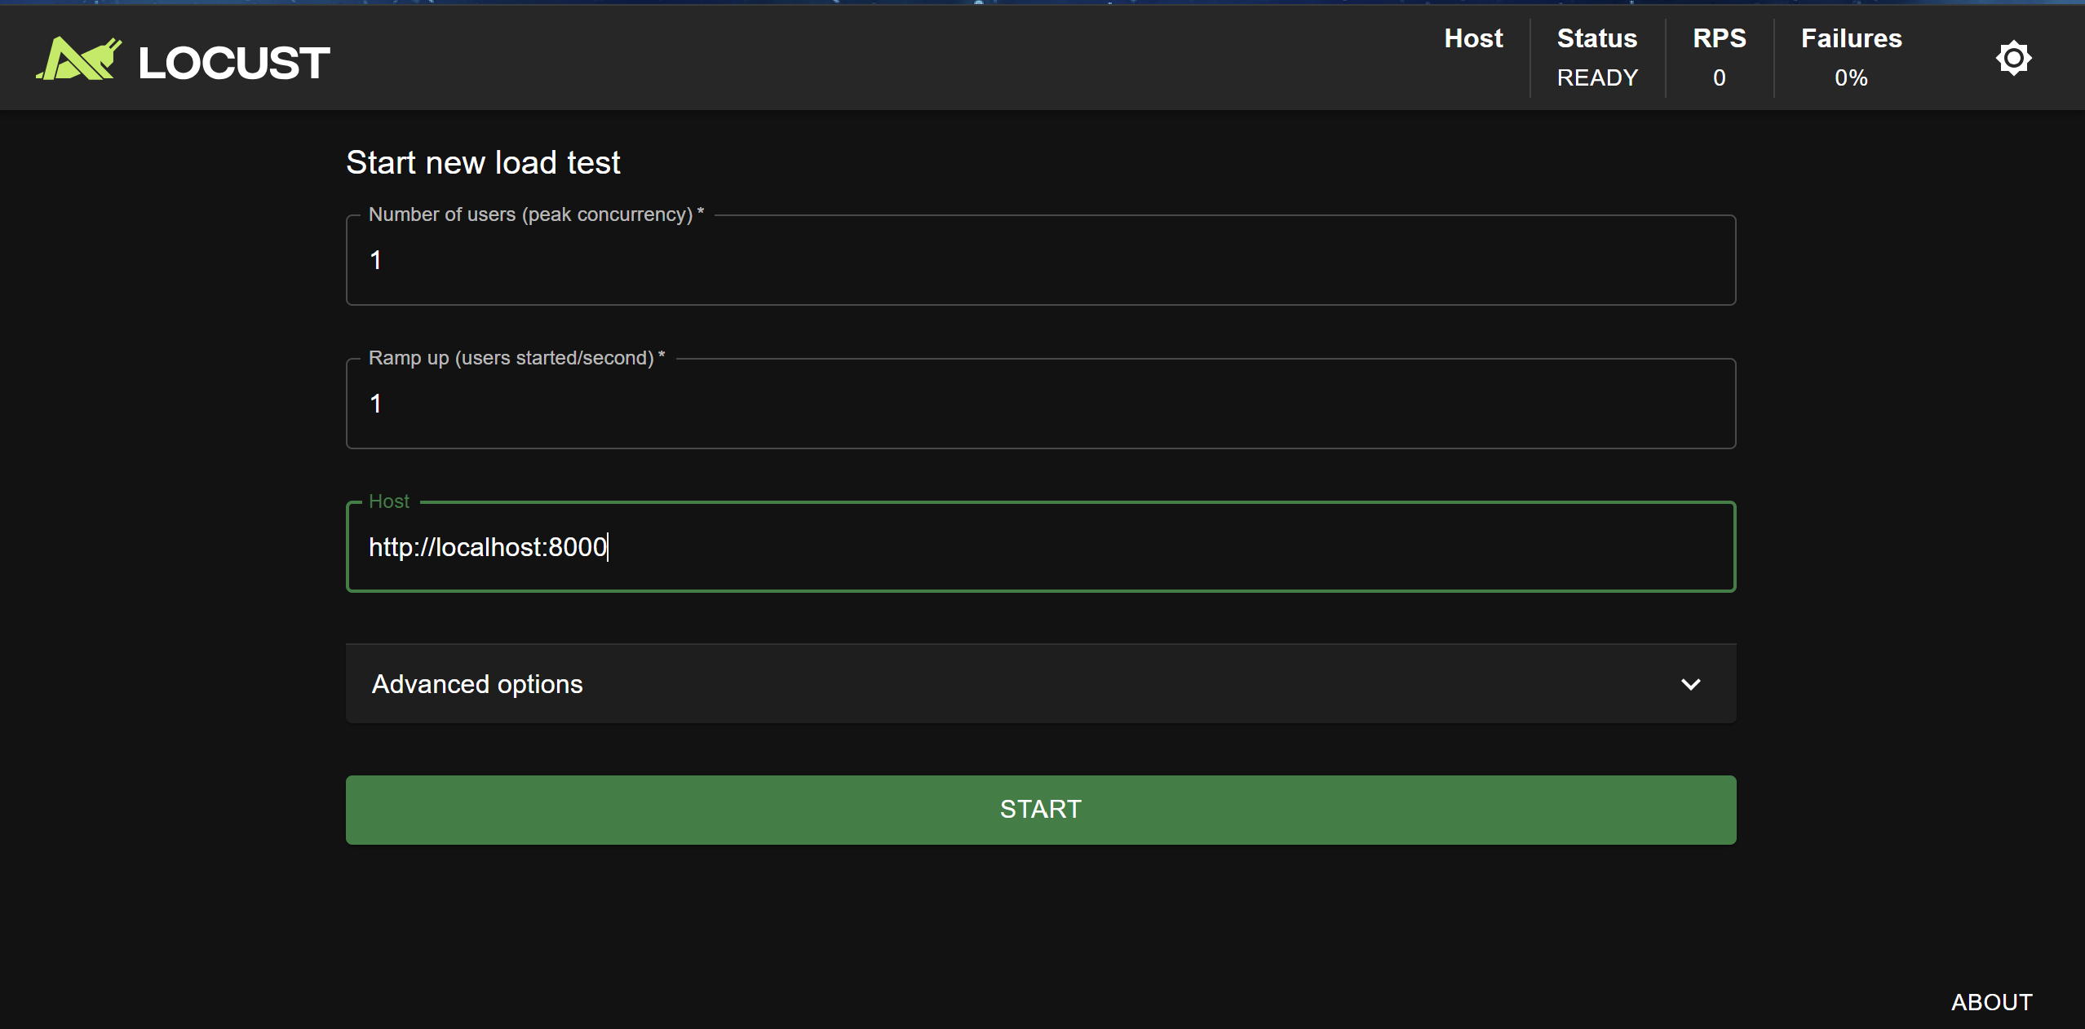

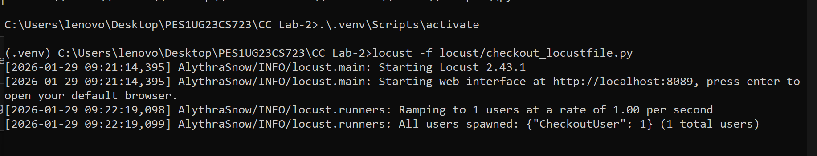

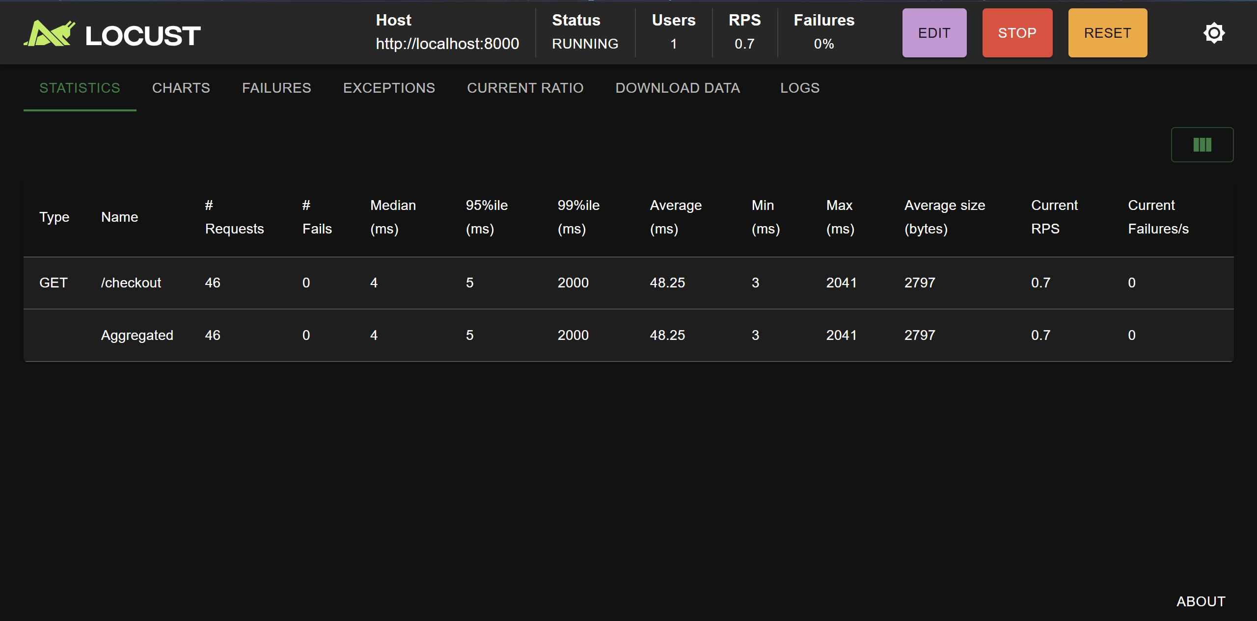

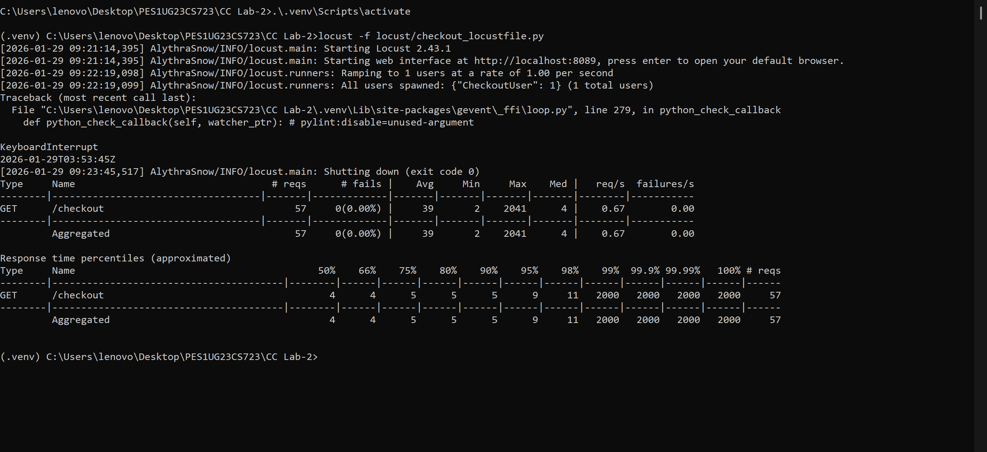

**PART 6**

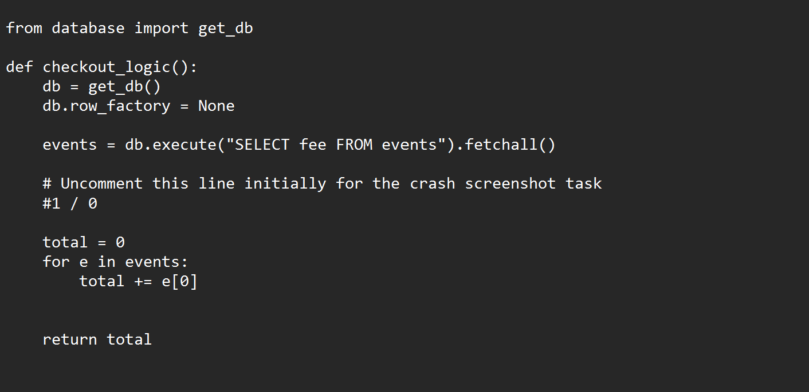

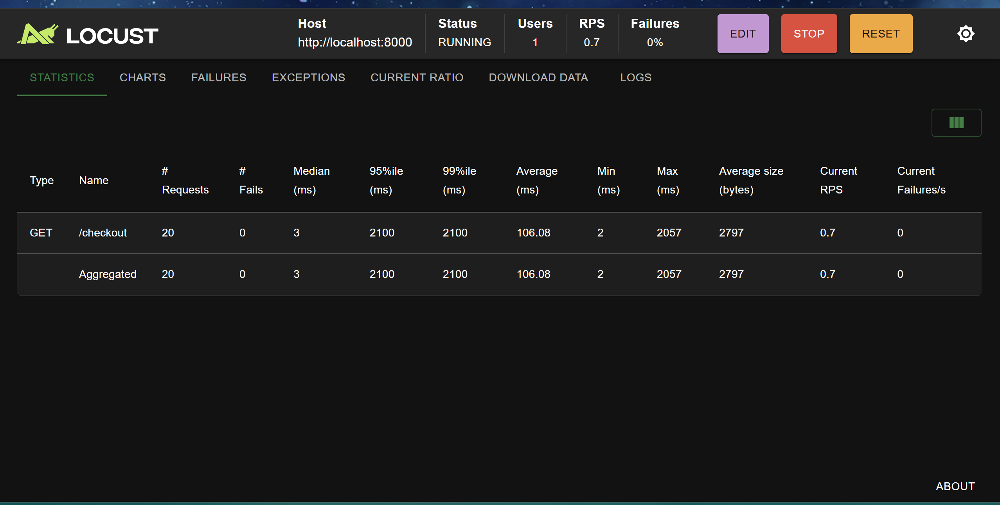

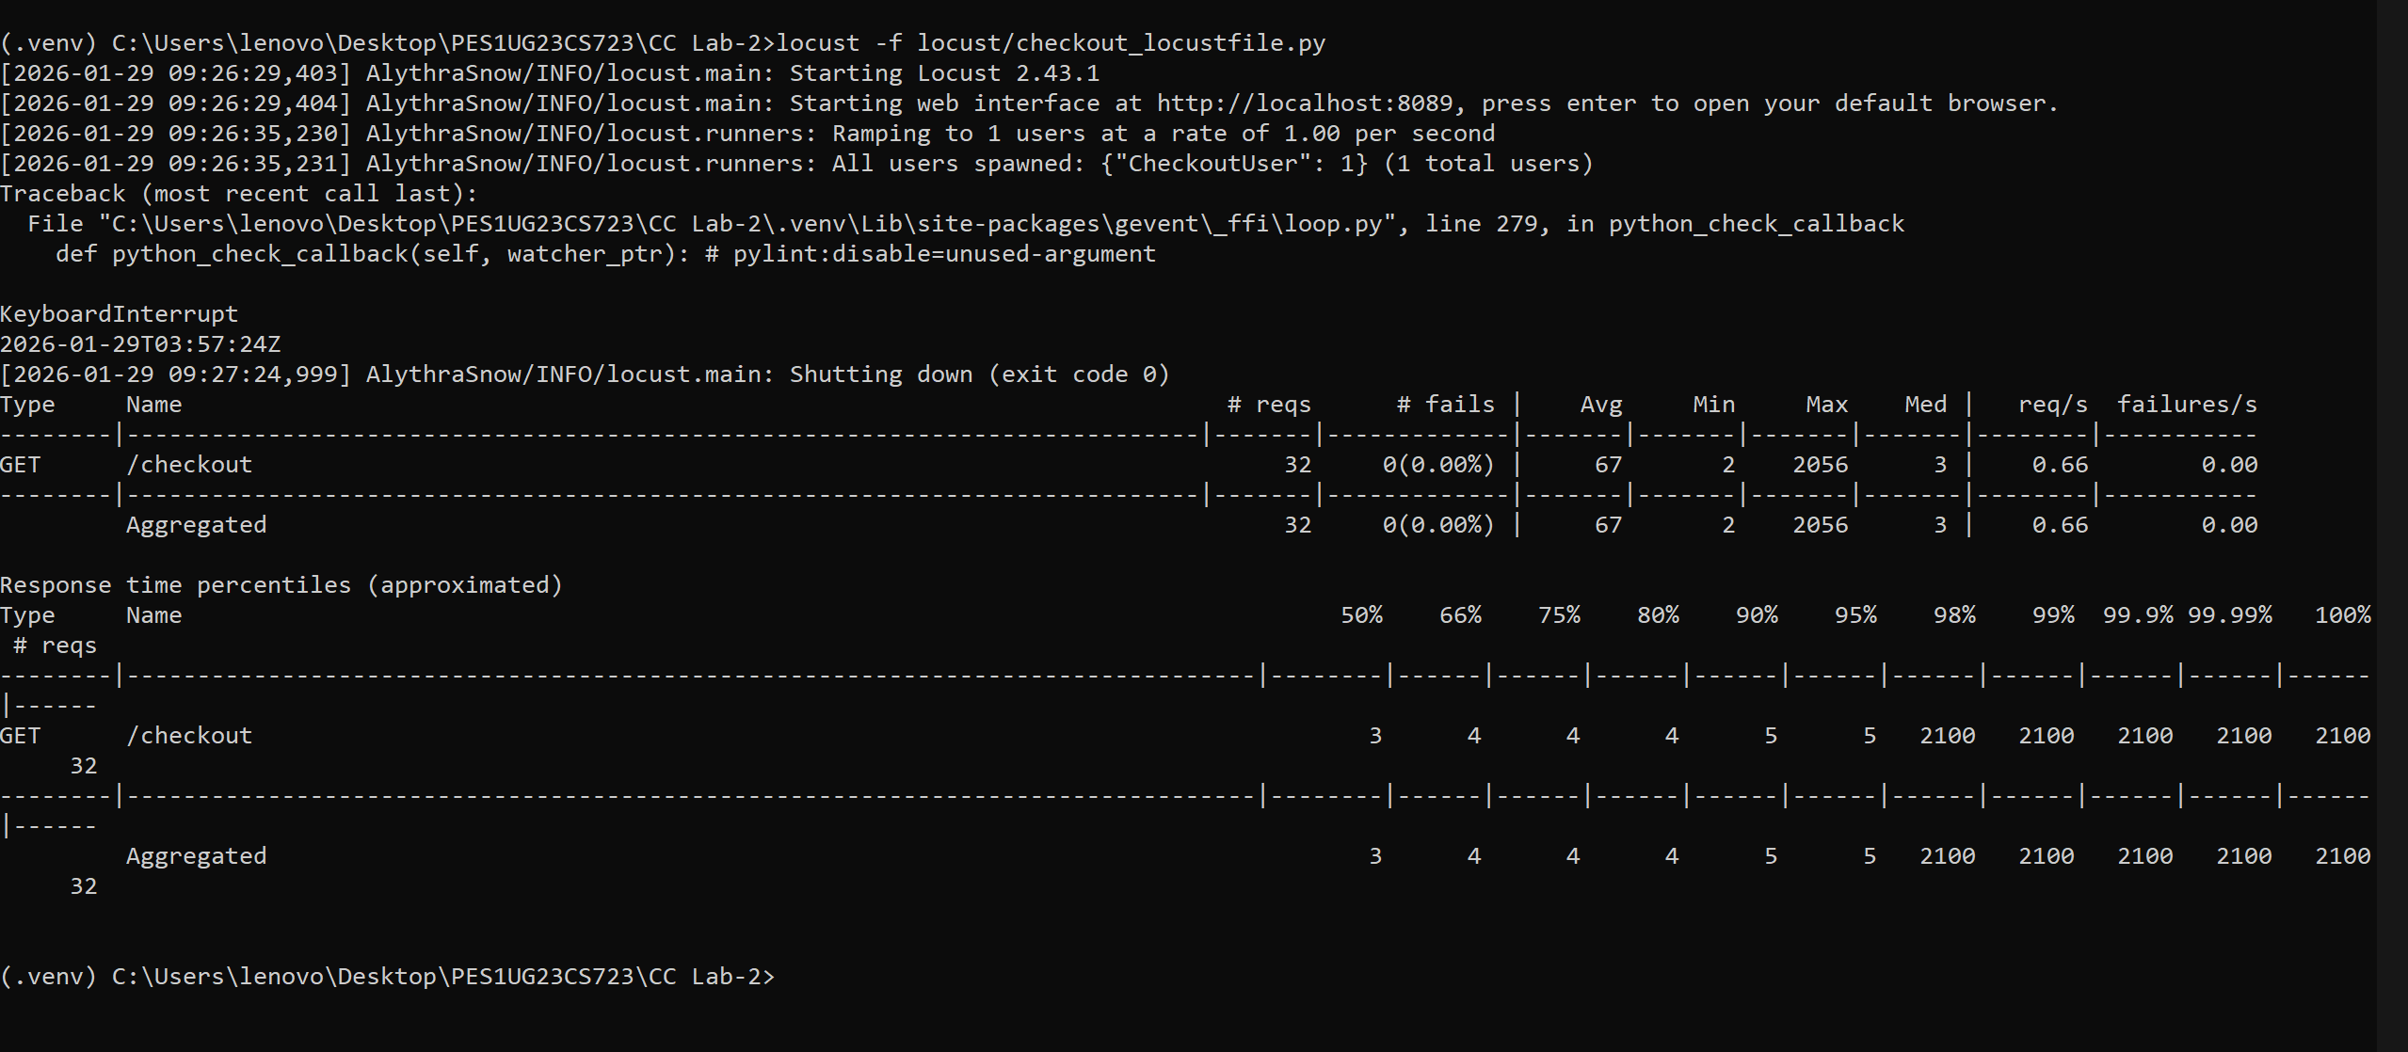

**TASK 7**

ROUTE 1

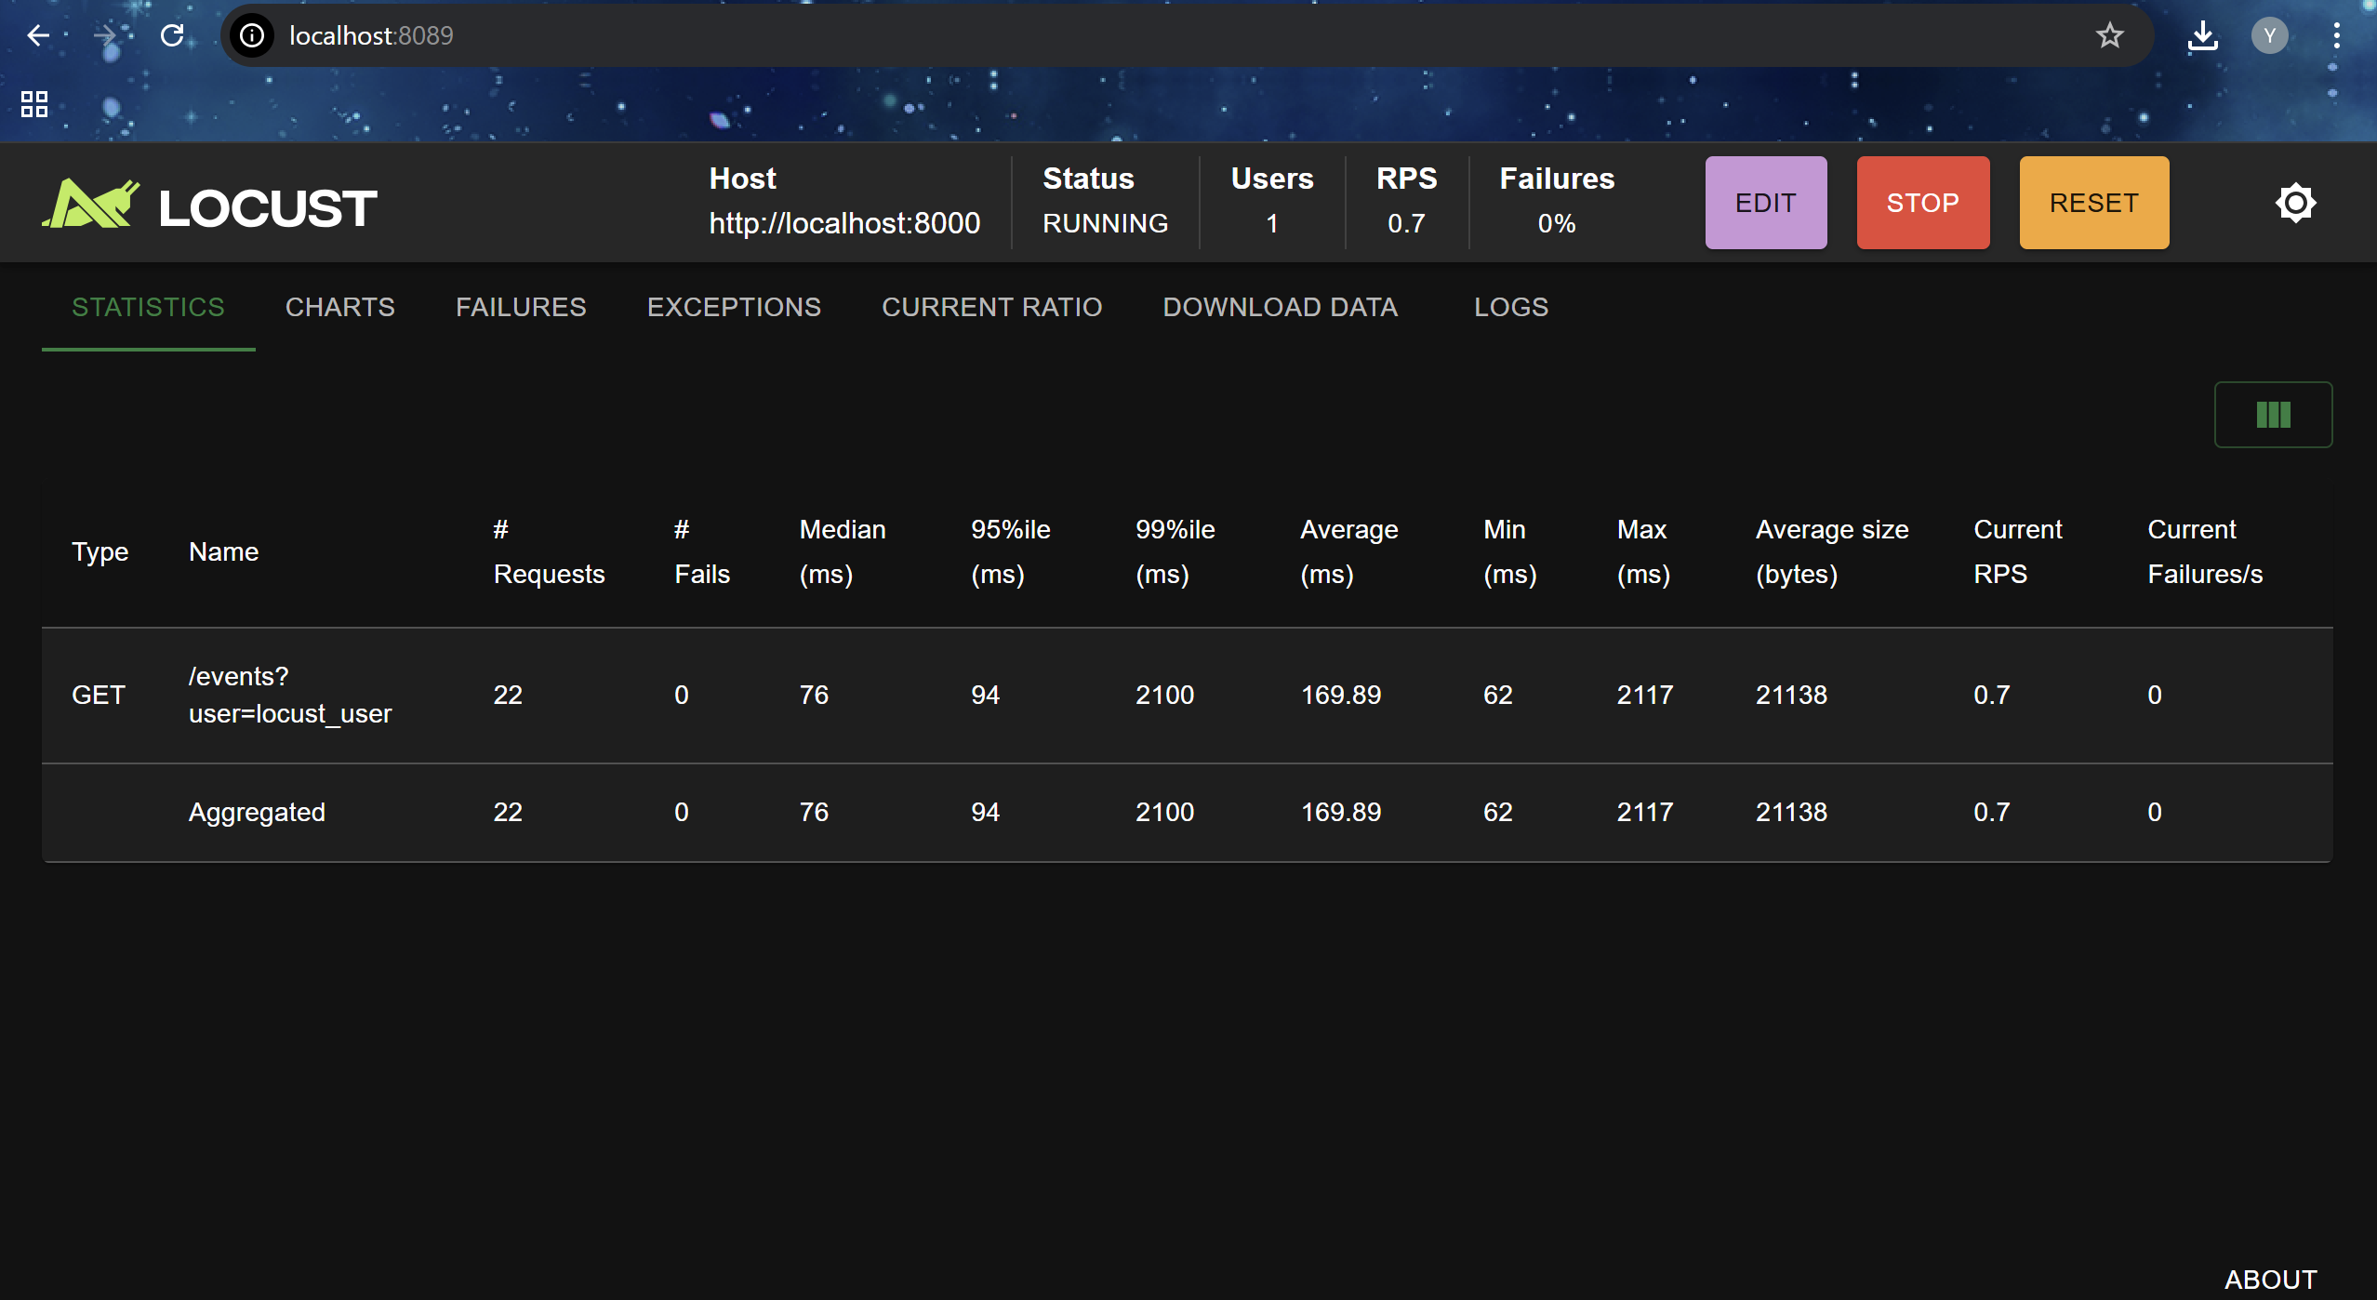

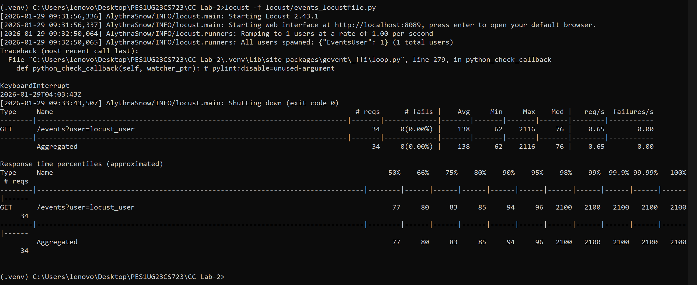

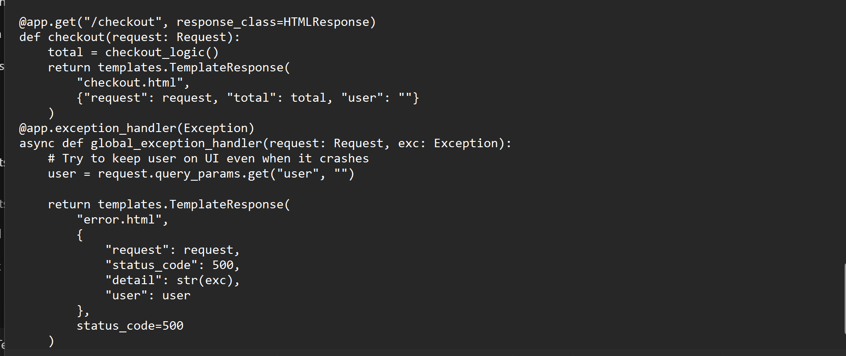

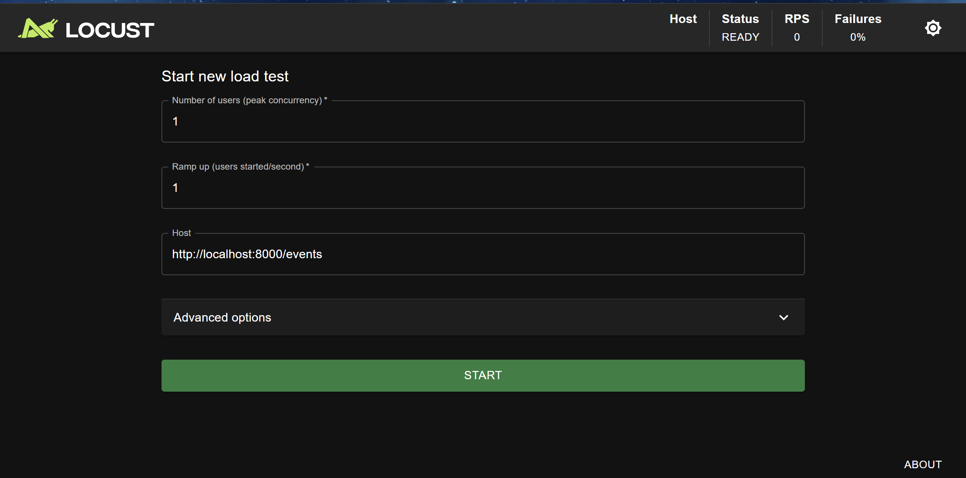

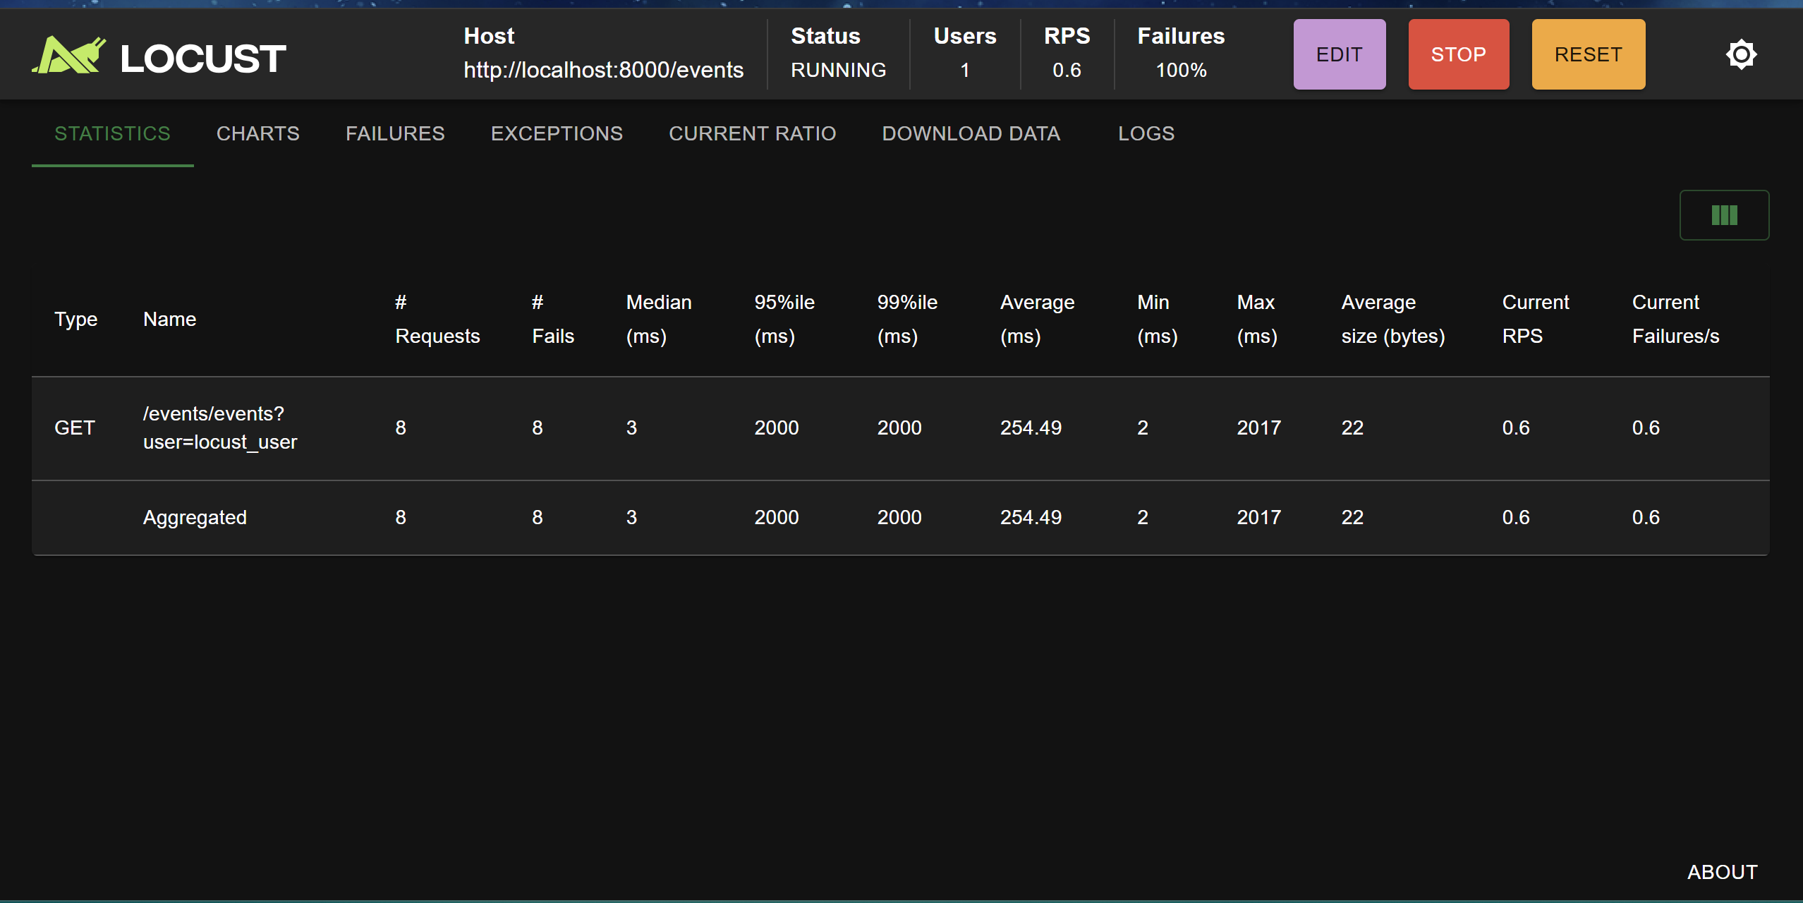

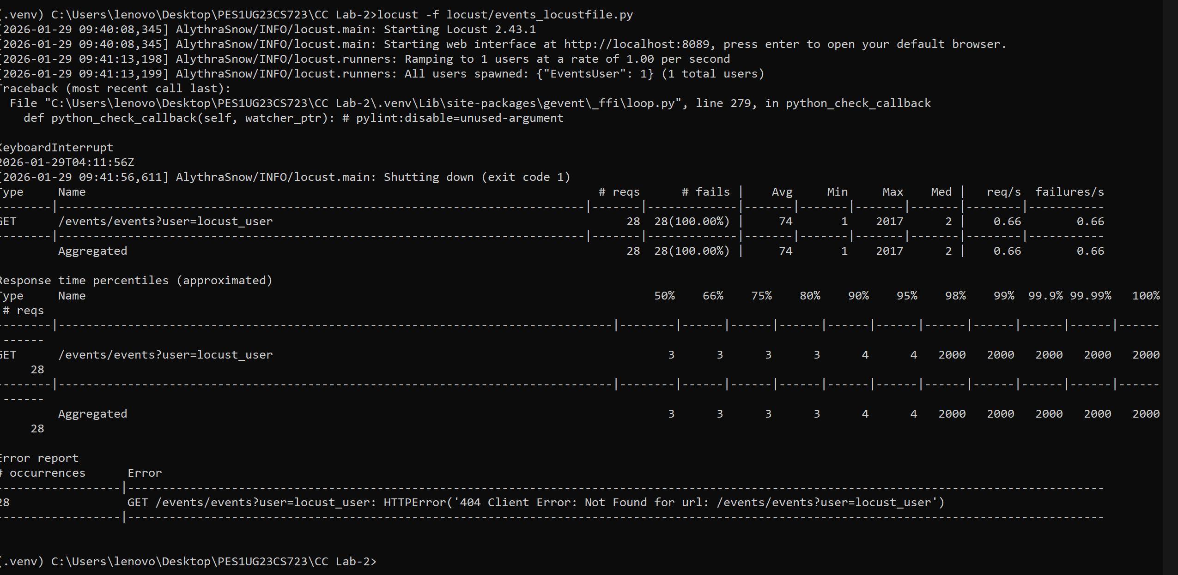

ROUTE 2

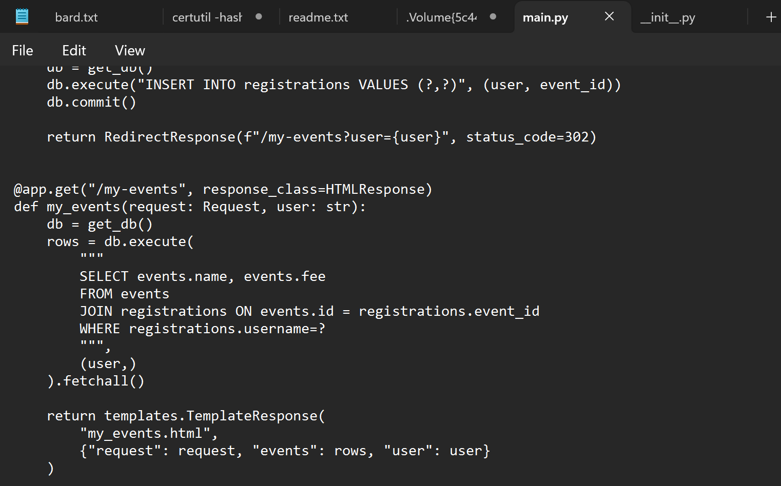

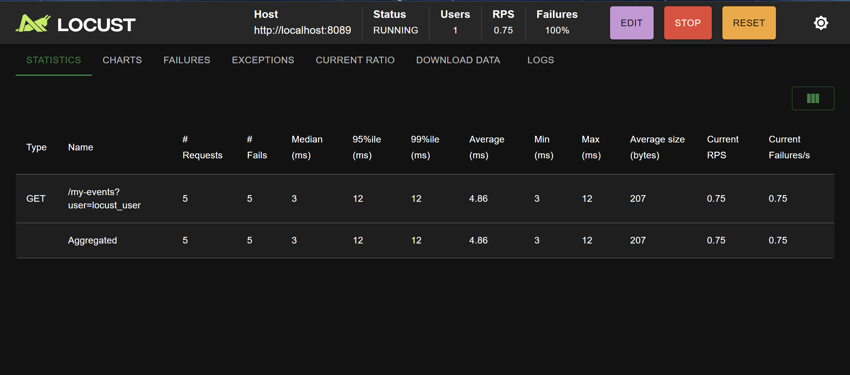

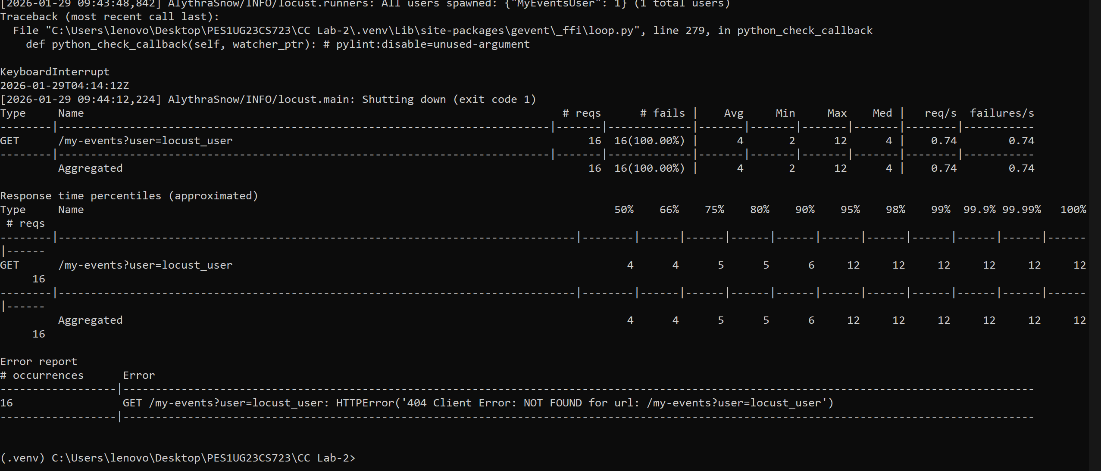

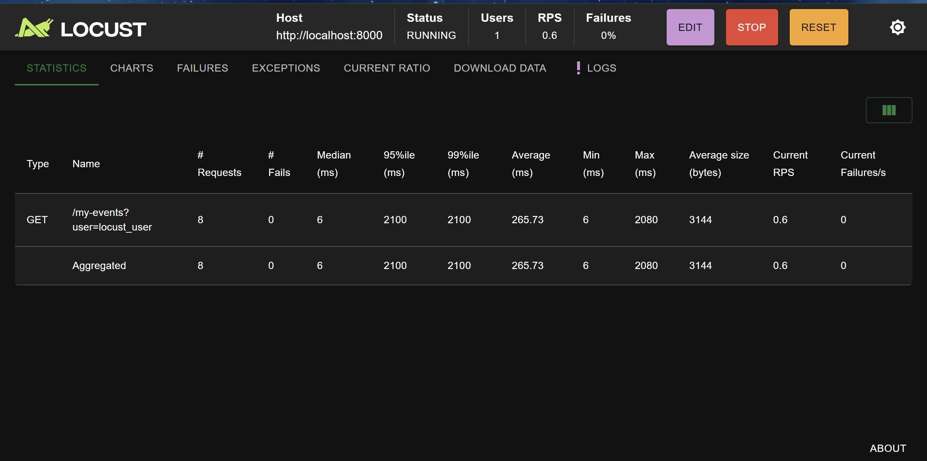

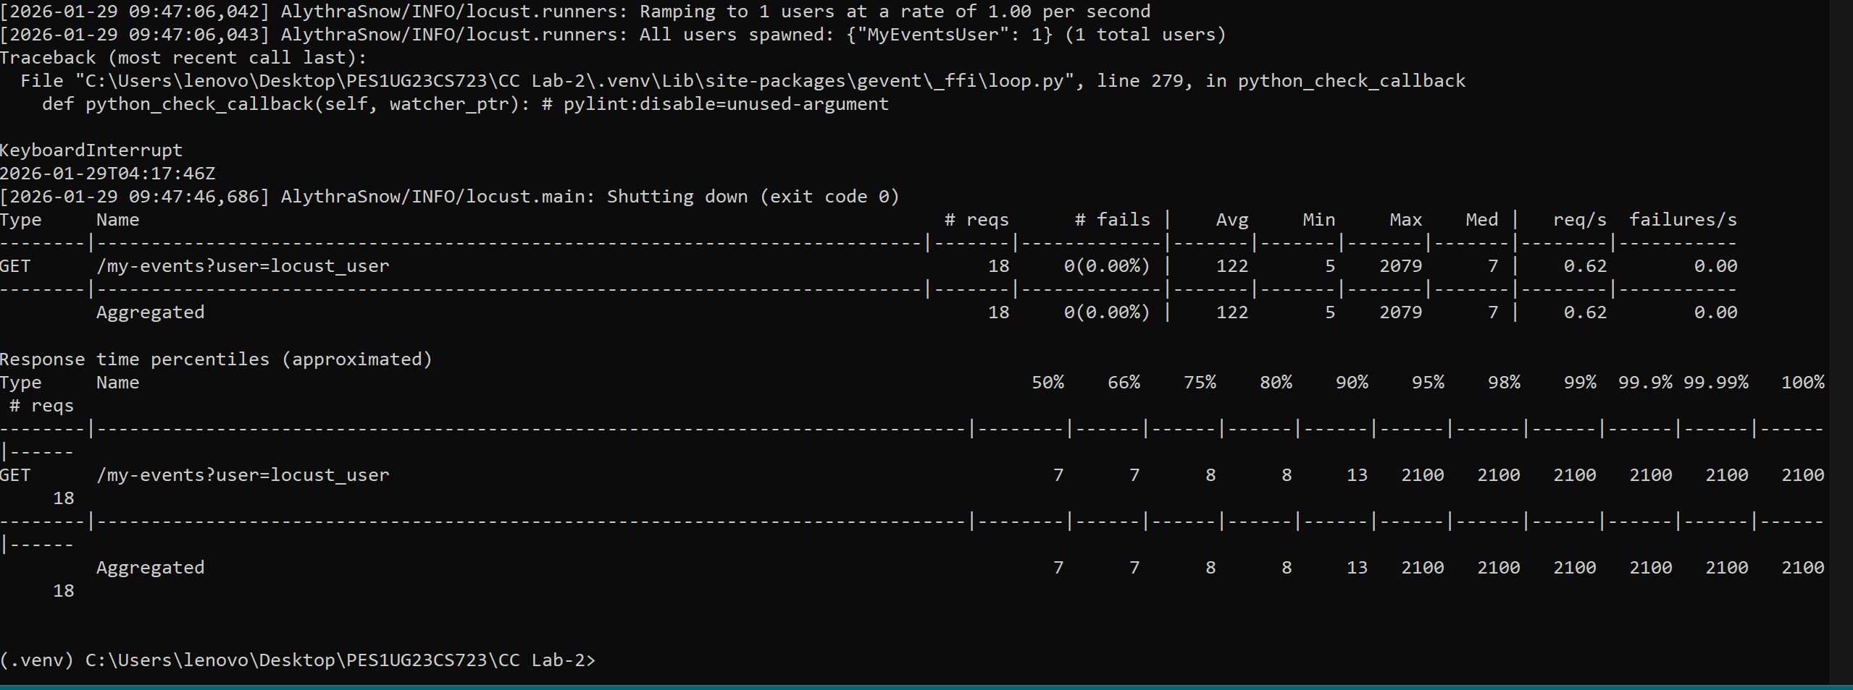

**QUESTION AND ANSWERS :**

**What was the bottleneck in the /checkout route?**

The checkout route contained inefficient logic that unnecessarily looped through values, increasing CPU usage and response time. This made the route slower under load.

**What change did you make to optimize /checkout?**

The inefficient loop was replaced with a direct and optimized calculation that summed event fees efficiently. This reduced unnecessary computation.

**Why did performance improve after optimizing /checkout?**

By removing redundant operations, the CPU workload was reduced. As a result, the average response time dropped while the system handled the same number of requests per second more efficiently.

**Route /events: What was the bottleneck?**

The /events route contained an unnecessary loop running millions of iterations. This loop did not contribute to functionality but consumed CPU time, slowing down the response.

**What change was made in /events?**

The wasteful loop was completely removed, allowing the route to simply fetch event data from the database and return it to the user.

**Why did /events performance improve?**

Removing unnecessary computation reduced CPU usage, allowing the server to respond faster and handle requests more efficiently.

**Route /my-events: What was the bottleneck?**

The /my-events route had a dummy loop that performed useless iterations, which slowed down the response time without adding any value.

**What change was made in /my-events?**

The redundant loop was removed, leaving only the required database query and template rendering logic.

**Why did /my-events performance improve?**

With the unnecessary computation removed, the server spent less time processing each request, resulting in faster responses and better performance.